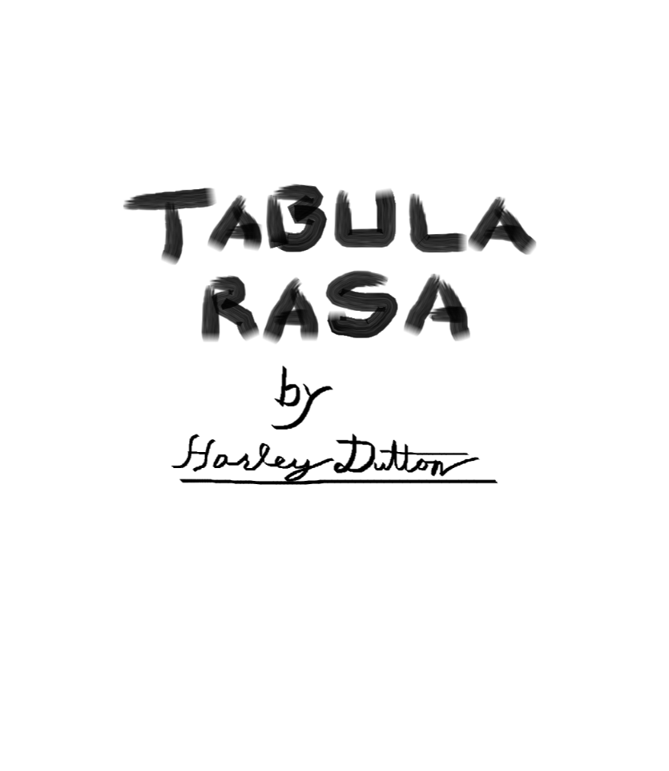

# **Introduction**

Tabula Rasa is a worldbuilding framework and a rules-light, generic roleplaying game that lets players create their own skills and add to the setting easily.

The worldbuilding framework produces a Setting. Settings are short, standardized, and easily shareable descriptions of a single place within a world. The intent is that Settings can be used to quickly understand a part of the world such that a player can create a Character or the Storyteller can create an Adventure.

The roleplaying system is generic so it will work with any Setting produced by the worldbuilding framework. The rules are minimal meaning you and your group should be able to create any character imaginable within the Setting and start playing very quickly!

## **Getting Started**

A night of role playing usually lasts anywhere from two to six hours and includes a variety of scenes: Exhilarating chases, nail-biting espionage, terrifying battles, grand speeches, descriptions of exotic lands, and, of course, joking around in and out of character are all hallmarks of good roleplaying.

One player will need to be the storyteller. The storyteller is largely responsible for running the game. A storyteller's responsibilities include setting up scenes between characters, planning and narrating events that drive the story, roleplaying NPCs, setting check difficulties, and managing the setting. Once a storyteller is chosen they should go take a look at the [setting](https://github.com/harleydutton/Tabula-Rasa/blob/develop/tabula-rasa.md#setting) section and either create or find a setting for their story.

Everyone else will be a player. Players should go straight to the [character creation](https://github.com/harleydutton/Tabula-Rasa/blob/develop/tabula-rasa.md#character-creation) section and begin creating characters using the setting provided by the storyteller. Once a player has a character, they will provide voice acting, motivations, and personality for the character in addition to controlling their actions in the story.

Most good stories include conflict. Once you have a storyteller, a setting, a story, and a character for each player you will need to know how to resolve conflicts. Conflicts are usually between characters and when they arise they can be resolved by rolling [checks](https://github.com/harleydutton/Tabula-Rasa/blob/develop/tabula-rasa.md#check). Everyone should make sure they understand how checks work.

## **Legend**

* examples of specific skills and flavor will be monospace in-line
* section specific keywords will be in bold
* sections will be referenced using [links](https://github.com/harleydutton/Tabula-Rasa/blob/develop/tabula-rasa.md#legend)
* larger examples will be quoted and appear under the relevant section with no header.
* interjections (like this) will be in parenthesis

## **Table of Contents**

Introduction

Getting Started

Legend

Table of Contents

Systems

Character Creation

Identification Information

Character Points

Motivations

Aesthetic Description

Flavor

Hooks

Boons

Attributes

Skills

Veto

Theme

Scope

Limiting Factors

Uniqueness

Speed

Printable Character Sheet

Checks

Difficulty

Nested Checks

Contests

DTMS Checks

Challenging

Character Progression

Character Point Acquisition

Flavor Acquisition

Crafting

Skill Acquisition

Skill Progression

Mandatory Skills Progression

Attribute Progression

Money

Trivial Purchases

Minor Purchases

Major Purchases

Impossible Purchases

Hidden Information

Oblivious

Undetected

Suspicious

Detected

Influence

Social Influence

Difficulty

Resistance

Mental Influence

Difficulty

Resistance

Distance

Zones

Battlefields

Movement

Damage, wounds, dying, death

Damage

Wounds

Dying

Death

Armor

Weapons

Timing

Tick Length

Action Delay

Global Ticker

Initiative

Surprise

Ties

Setting

Action Delay

Character Points

Skills

Technology and Magic Descriptions

Store

Tone

Social Description

Physical Description

Theme

Character

Identification Information

Action Delay

Character Points

Motivations

Skills

Attributes

Skills

Flavor

Bad Flavor

Deals

Items

Money

Social Flavor

Supernatural Flavor

Relationships

Knowledge

Vehicles and Properties

Physical

Glossary of Terms

# **Systems**

This section goes into detail on the typical systems involved in roleplaying and how this game choses to do them instead. Some of these will be very far from typical given that there is no source material to reference for skills, items, monsters, etc.

## **Character Creation**

To make a character first read through the setting document your storyteller has provided you with. When you have done this and understand the world you will be playing in read through this and fill in the sections for the character sheet--located at the end of this section--using what you have learned. Ask your storyteller for help with things you do not understand or consult the table of contents.

### **Identification Information**

These things go on your sheet to keep you and your storyteller sane in real life. You can omit these things if you like but it is not recommended and I already carved out some space on the sheet for it.

* Name: The character's name
* Character concept: ?
* Player: The player's name
* Setting: The name of the character's setting
* Story: The name of the story the character was in
* CPaquired and spent

The storyteller should be tracking the CP they have distributed to the group on the setting document. Each player should be keeping track of how much of this they have not spent on their character sheet such that they can easily take new skills.

### **Motivations**

Tell me why your character gets out of bed in the morning. What is their purpose? Do they seek revenge? To protect something? Are they on the run? Do they want to be respected? Are they searching for something? Do they have any ideals that they follow? These are all motivations that will give a storyteller a good way to interact with your character. You must have at least one and you should consider taking a few.

### **Aesthetic Description**

This is a good place to describe your character's gender, age, weight, build, height, bearing, clothes, stereotypical class, etc. The purpose of this section is to give other players or the storyteller an idea of what your character looks and acts like. If you want anything here to influence your rolls it should also be added to flavor.

### **Flavor**

Flavor is a word or short phrase describing your character. While you could say your character has clothes and the ability to speak, let's not worry about that and instead focus on the things that spice your character up! Flavor can include knowledge, possessions, physique, and even social position. Most flavor costs one CP at character creation or one hook for those which are particularly powerful. More flavor can be obtained or inflicted later on in the game.

### **Hooks**

**Hooks** are a special piece of flavor that the storyteller can use to interact specifically with your character to create tension within the story. Adding a hook to your character is the typical way to go about getting a boon and it also integrates your character into the story a little better most times. A hook can be a love interest, an enemy, a debt, a cause, a disability, and much more. When you would like to add a hook to your character you must first discuss it with your storyteller and if they agree to let you take the hook you also get a boon. Hooks are distinct from motivations in that they don't always come from within e.g. being #17 on the FBI most wanted list.

### **Boons**

**Boons** arethe extra powerful version of flavor. Boons can only be obtained through hooks. Boons allow characters to be abnormally large, a powerful non-human, unusually rich or famous, or have a magic skill, or some smart, loyal minions. Boons can also be exchanged for a renewable major purchase.

.**Skills**

Skills are the most mechanical part of a character. They allow your character to make actions by rolling checks. Skills have levels and are usually self-descriptively named though there is space for skill descriptions on the character sheet. You can purchase skills with CP at character creation and level them up later using CP.

pickpocket, pyromancy, intimidation, stealth, clairvoyance, and blocking are all examples of skills.

#### **Attributes**

Attributes Body, Mind, Spirit and Social. They are similar to skills but have meaningful differences. First, every character gets the first level of each attribute for free. Second, attributes cost significantly more CP to level up than skills do. Third, attributes are broad and if a character does not have an applicable skill they can roll an attribute. For this reason attributes are frequently used as defensive skills and for perception checks. Lastly, attributes represent a character's physical, mental, spiritual, and social health. This is discussed in more depth in the Damage section.

| **Level** | **1** | **2** | **3** | **4** | **5** | **X** |
| --- | --- | --- | --- | --- | --- | --- |
| CP Cost | 0 CP | 4 CP | 9 CP | 16 CP | 25 CP | X*X CP |
| Total CP | 0 CP | 4 CP | 13 CP | 29 CP | 54 CP | (X(X+1)(2X+1)/6)-1 CP |

#### **Skills**

Skills are listed on the setting. This should include all of the skills the players or storyteller have added to the setting. These skills are available within the setting to any character passing a DTMS check and can be purchased as normal.

| **Level** | **1** | **2** | **3** | **4** | **5** | **X+1** |
| --- | --- | --- | --- | --- | --- | --- |
| CP Cost | 1 CP | 2 CP | 3 CP | 4 CP | 5 CP | X CP |
| Total CP | 1 CP | 3 CP | 6 CP | 10 CP | 15 CP | X(X+1)/2 CP |

**Adding to the Setting**

It is the intent of this system that you can play what you want. Players can speak with the storyteller and propose things to be added to the setting. If you want to play a cat-man samurai talk to the storyteller about adding cat-men to the setting and if samurai need special skills or tools to be relevant, propose those too. If the storyteller agrees, "Boom!", you can play what you want.

#### **Veto**

The storyteller can reject your additions to the setting for any reason. You can bitch and moan but ultimately the storyteller is the one telling the story and doesn't have to put your idea in the story no matter how much you want it there. Come up with a new idea.

@Storyteller: In the interest of reducing arguing, bitching, and moaning, give a reason for your veto.

#### **Theme**

A common reason for an addition to a setting to be rejected is because of theme. Don't try to play a wizard in a non-magic setting. Don't try to play a jedi in a medieval setting. Sure there are storytellers who will jump at that but try to stay within the themes outlined in the setting document.

#### **Scope**

Many times, players will try to create skills that are much too broad in scope. Less frequently, players will make skills that are too narrow in scope. Loosely speaking scope represents the percentage of situations a skill can apply to. An example of a skill that is too broad is magic as you can do anything you want with it. A skill that is too narrow would be death curse as it can only be used to kill someone. Somewhere in between we find the skill death magic which has many applications but not infinitely many. It has a specific domain in which it is useful. Storytellers should specifically look out for skills that are too broad during character creation and veto them.

#### **Limiting Factors**

If you create a skill with appropriate scope that is just too powerful for the setting or story your storyteller may inflict a few limiting factors upon the skill you have proposed or your character.

@Storyteller: A few good limiting factors are timing restrictions(requires multiple turns in combat, cannot be done in combat, takes multiple days, etc.), resource costs (add a mana bar, minor purchases, major purchases, etc.), context restrictions (must have line of sight, must have eye contact, must be touching the target, must have a piece of the target, etc.), and cooldowns (AUTs or turns, once per combat, once per day, refreshes randomly, etc.).

#### **Uniqueness**

When you add something to the setting you may have it in your head that it will be unique. You will be the only fire mage, you will have the only gun, you will be the only alien, etc. This can very quickly lead to an unbalanced and unenjoyable setting or story. Do not expect to have a monopoly on anything you add to the setting. Where there is one, there can be two.

### **Speed**

This is how long your character has to wait to do things in combat. Lower means faster. If you would like to decrease your action delay you can do so by spending CP. The default action delay is 10 but you should take a look at the setting document provided by your storyteller to make sure.

| **Default** | **-1 AD** | **-2 AD** | **-3 AD** | **-4 AD** | **-5 AD** | **-X AD** |  |
| --- | --- | --- | --- | --- | --- | --- | --- |
| Cost for -1 AD | 0 | 1 CP | 4 CP | 9 CP | 16 CP | 25 CP | X*X CP |
| Total cost | 0 | 1 CP | 5 CP | 14 CP | 30 CP | 55 CP | ... |

**NPCs**

. If you go through the character creation process for an NPC, you should end up with a character of similar power level to the PCs, assuming you use the same amount of cp. If they need to be combat capable make sure they have an AD. If they are there to talk make sure they have *at least* one motivation. Leaving a large chunk of an NPCs CP unspent is a good way to keep them flexible.

### **Printable Character Sheet**

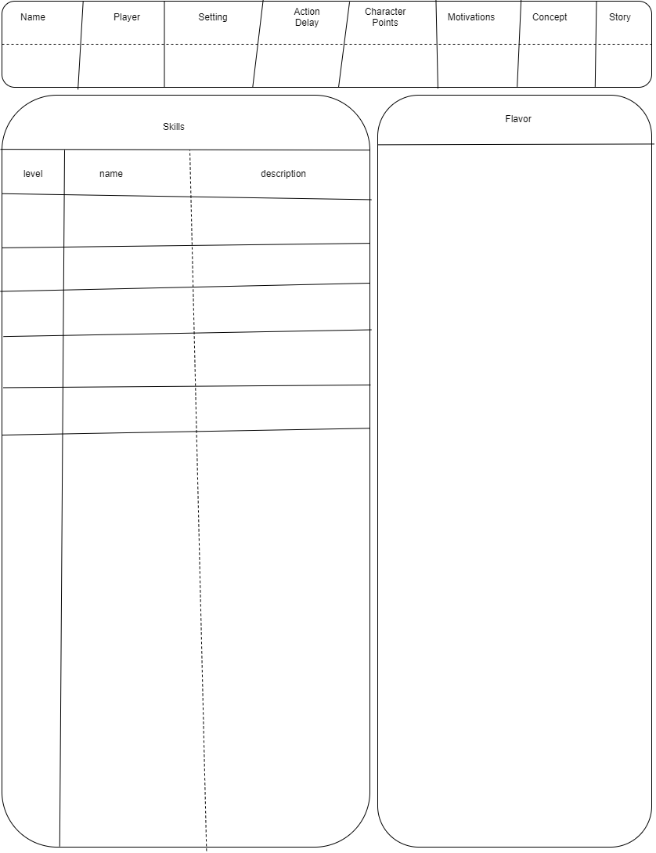

## **Checks**

When conflict occurs during roleplaying, most of the time, the fairest way to resolve it is by rolling a skill check, or check for short. You can always use one of the mandatory skills (mind, body, spirit, and social) or you can use another relevant skill your character has. Tell the storyteller what you want to do with your skill and feel free to be specific--Actually specific is better. The storyteller will set a subjective difficulty (target number) for the action. At this point you have options. You can roll, abort, or challenge the difficulty the storyteller set. Roll a number of dice equal the skill's level. If any meet or exceed the target number you pass the check and what you described happens.

If Sam wants to jump over a river and has an `athletics` skill of 5, Sam would say "I want to jump across the river." The storyteller might tell him "that will be hard because the rain made the ground muddy and your footing is bad," which means the target number is 6 instead of 5 on a six-sided die. When Sam rolls, if any one of Sam's 5 dice come up as a 6, Sam successfully jumps across the river. On the other hand, if Sam does not get any sixes, he fails to jump across, likely resulting in him landing in the river.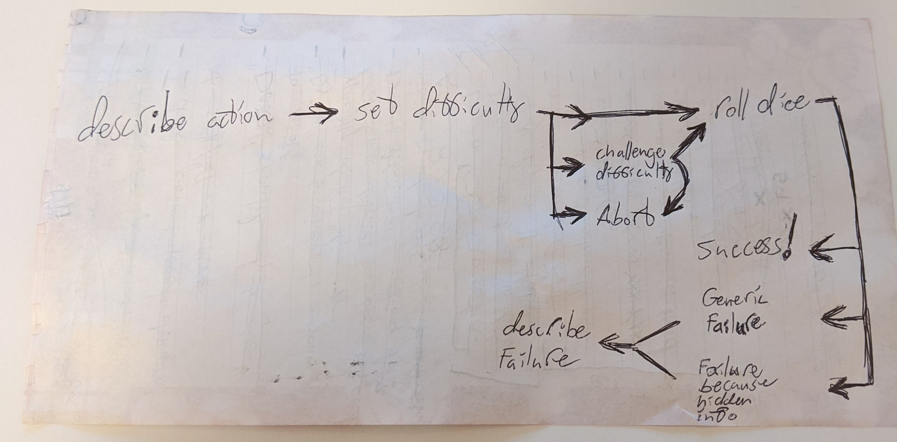

### **Difficulty**

The storyteller can assign a check five different difficulties: Trivial, Easy, Normal, Hard, and Impossible. The difficulty of a skill check can be modified by flavor, context, or the innate ease or difficulty of the action itself. The storyteller decides if any of these things is meaningful enough to change the difficulty. The subjective difficulty of a roll translates directly to a target number, meaning when you roll a check only dice that are greater than or equal to the target number count as successes. The players can challenge the difficulty the storyteller has prescribed if they wish.

| **Difficulty** | **Trivial** | **Easy** | **Normal** | **Hard** | **Impossible** |
| --- | --- | --- | --- | --- | --- |
| Target Number | Automatic Pass | 4 | 5 | 6 | Automatic Fail |

### **Nested Checks**

When you want to perform an action involving multiple different skills you might have to make a nested skill check. What this means is that you roll a check for each skill involved and if any of them fail the action fails. If they all succeed the action succeeds.

To back flip down some stairs while shooting a fireball up the stairs you would need to pass both acrobatics and fire magic checks.

### **Contests**

Contests are where two or more characters are trying to be best at some action. The problem comes in that there is a good chance both characters will succeed and so we must use magnitude of success to determine the winner of the contest. You only need one success to pass a skill check. Any successes beyond one contribute to magnitude of success. The character with the highest magnitude of success wins the contest. When the magnitudes of success are tied there is a tie.

Racing, feats of strength, public debates, drinking contents, and gambling are all common contests.

### **DTMS**

There is one special kind of check that the storyteller will make frequently. These are DTMS checks which stands for "Does this make sense?" They don't use dice and they aren't a check in the traditional sense. DTMS checks are just a way for me to shorthand the idea "use your brain to decide if this should be allowed or not."

### **Challenging**

When a player disagrees with the difficulty of a check they can challenge the difficulty the storyteller has set. When a player challenges the difficulty of a check, this means they are asking the table to vote for what they think the difficulty should be. The storyteller's vote counts as 1.5. The purpose of this system is to deal with storytellers who are a little unfair some of the time, not make all checks **easy**. Each check can only have it's difficulty challenged once.

## **Character Progression**

Characters usually get stronger over the course of a story. They can acquire new skills, level up the existing ones, and get new flavor including but not limited to items, social status, and followers.

### **Character Point Acquisition**

Character points are given by the storyteller at character creation and usually also session by session. Character points are typically awarded for heroics, good roleplaying, and completing quests. The storyteller should keep a running total on the setting document of how many CP have been given out to the group.

### **Flavor Acquisition**

Your character will acquire flavor throughout the story for mostly for free. You can, however, pay for it in the same way as you would during character creation. Hooks and boons can be acquired through roleplaying, items and other things worth one CP can be obtained from stores where available, and temporary wound flavor is the natural result of combat. Beware, actions have consequences and sometimes flavor will be inflicted upon you.

#### **Crafting**

In Tabula, crafting an item is just a skill check. Describe what you want and how you plan on using your crafting skill to get it, ask the storyteller what the difficulty is, and make the roll. If you succeed you get the desired item, likely with some narrative flair. If you fail you do not get what you asked for, any materials and time put into the crafting roll are lost, and it is possible something bad happens.

### **Skill Acquisition**

Skills can be learned from other characters in the story. If a skill is fairly simple or if a character is fairly dedicated they can learn it on their own. Dedicated characters can also create new skills and add them to the setting--once again, only with storyteller approval. The first level of any new skill costs one character point. All skill acquisitions need to pass a DTMS check.

### **Skill Progression**

Leveling up skills can happen at any time and requires CP. The CP cost varies by level and type of skill. Mandatory skills are significantly more expensive than available skills to level up.

#### **Mandatory Skills Progression**

Mandatory skills are Body, Mind, Spirit and Social. The cost to level a mandatory skill is the desired level squared in CP. You must level up skills one level at a time.

| **Level** | **1** | **2** | **3** | **4** | **5** | **X** |
| --- | --- | --- | --- | --- | --- | --- |
| CP Cost | 0 CP | 4 CP | 9 CP | 16 CP | 25 CP | X*X CP |
| Total CP | 0 CP | 4 CP | 13 CP | 29 CP | 54 CP | ... |

#### **Attribute Progression**

The attributes are Body, Mind, Spirit and Social. The cost to level an attribute is the desired level squared in CP. If you wish to raise an attribute more than one level at a time you must still pay for the intermediate levels.

| **Level** | **1** | **2** | **3** | **4** | **5** | **X+1** |
| --- | --- | --- | --- | --- | --- | --- |
| CP Cost | 1 CP | 2 CP | 3 CP | 4 CP | 5 CP | X CP |
| Total CP | 1 CP | 3 CP | 6 CP | 10 CP | 15 CP | ... |

## **Money**

In Tabula money has been abstracted away as annoying bookkeeping. Many common items will be effectively free. When you actually have money it will usually be the flavor minor purchase or less commonly a major purchase. These purchases can be roleplayed as being whatever the native currency of the world is be it gold coins, bank notes, or space-bucks. To understand how these purchases will spend take a look at the store chart on your setting.

This is the store from Sequoia, the example setting.

| **Trivial** | **Minor** | **Major** | **Impossible** |
| --- | --- | --- | --- |
| food | armor | training | metal |
| water | weapons | ironwood |  |
| torches | tools | land |  |
| entertainment | animals | vehicles |  |
| consumables | luxuries | medicine |  |
| lodging | meat | AEther |  |
| booze | jewelry | magic items |  |
| clothes |  | allies |  |
| materials |  | boons |  |

### **Trivial Purchases**

Many common things characters will need are effectively free so as to avoid pointless bookkeeping. The idea here is that each character has some way of paying for their adventures, and that when they get back home, they have a roof over their head and food in their belly because *something* they do is profitable, either back home or on the road. Typically food, clothes, ammo, and lodging end up on the list of trivial purchases but a storyteller might want to make you sweat by making one of your basic needs non-trivial.

### **Minor Purchases**

The idea behind minor purchases is that while they aren't everyday purchases they are easy to get. Tools, weapons, vehicles, jewelry, and luxuries all typically fall into this category. You can convert your character's character points into minor purchases at a one-for-one ratio but you cannot typically convert them back. The minor purchase flavor can be used to pay for goods and services under the "minor" column of the setting's store. A character can have multiple copies of the minor purchase flavor.

### **Major Purchases**

Major purchases are very similar to minor purchases except that they are worth more. Typically, to obtain a major purchase, you will have to give the storyteller a hook for your character or give up a boon. The major purchase flavor can be used to pay for things in the "major" column of the setting's store. Leadership of an organization, elite training, property, and spaceships are all roughly the same value as the flavor major purchase. Furthermore, major purchases can also be used to pay off hooks or purchase new boons.

### **Impossible Purchases**

Lastly and of least importance we have impossible purchases. There isn't much to say here really. You typically can't obtain these things for one reason or another. They might be illegal, one-of-a-kind, insanely expensive, or simply non-existent in the setting.

## **Hidden Information**

Hidden information in roleplaying games can range from lying, to sneaking up on someone, to hiding things. Hidden info is a source of tension and surprise but resolving can be tricky. The way I like to think about it there are two roles when talking about hidden information. One is the thief, the character going around hiding information. The other is the guard, the character trying to discover this information. The information the thief hides can be undiscovered or discovered. The guard can be suspicious or unsuspicious. Because it will almost certainly come up, it is worth noting that the difficulty of checks related to hidden information should be disclosed by default but doesn't have to be revealed before or even after the check is made. Whenever the thief wishes to hide info or change hidden info they need to make a check.

### **Oblivious**

Oblivious is a state for the guard and represents that the guard does not know the hidden information and doesn't even know it exists. This is the default state for every character. At any time a player can announce that their character is suspicious and begin being treated that way. NPCs typically need a reason to become suspicious.

### **Undetected**

Undetected is a state for the thief's hidden info and represents that the thief has successfully hidden it and that the guard might know it exists but hasn't detected it. When the thief wants to hide info or change hidden info, if there is a guard who could detect them, they need to pass a relevant check. Lying, stealth, disguise, traps, pickpocket, etc. are skills they might use.

Actions to hide information: Lying, moving silently, putting on a disguise, setting a trap, picking a pocket, etc.

### **Suspicious**

Suspicious represents the state where the guard knows the thief's hidden information exists but doesn't have it. At this point the guard can start making checks to attempt to uncover the hidden info. Pass or fail, when the guard stops looking for the information they should be considered unsuspicious. The guard might use seeing, hearing, some extra-sensory perception skill, a domain-specific skill like animal handling, or a mandatory skill to try and detect the hidden information.

As a guard on duty, some reasons to become suspicious: Nervous stuttering, heard a noise, clothes don't fit well, saw a wire, felt something in pants, etc.

### **Detected**

The thief's hidden information has been detected by the guard. No further checks need to be made and the situation can be played out.

Discovered the thief's lie, saw the thief sneaking up, saw through the thief's disguise, saw the thief's trap, etc.

## **Influence**

When one character uses a skill to make another character do something the first character is exerting their influence. These situations can quickly break the game or make it unenjoyable unless there is counter play. This section defines a system for resolving these situations. For this section the salesman will be the character exerting influence and the mark will be the target of their influence.

### **Social Influence**

Social influence is when the **salesman** uses their demeanor and way with words to convince the **mark** to do their will. The skills persuasion, seduction, bartering, intimidation and of course the social attribute are the usual suspects.

#### **Difficulty**

Before the salesman's influence check is made the storyteller should check the mark's motivations. Social influence checks are affected by the mark's [motivations](https://github.com/harleydutton/Tabula-Rasa/blob/develop/tabula-rasa.md#motivations) as well as flavor.

#### **Resistance**

Social influence is typically not resisted unless the character has a reason to do so. PCs may always choose to resist social influence. When social influence is resisted the mandatory skill social, or a more apt skill, is used to roll a check. The mark's [motivations](https://github.com/harleydutton/Tabula-Rasa/blob/develop/tabula-rasa.md#motivations) can have an effect on this check as well.

A guard has obvious reasons to not tell you about the secret entrance and should resist. A child has little reason not to carry your message to the mayor when you ask him.

### **Mental Influence**

Mental influence is when a character uses magic or some other plot device to subvert the will of the mark. The best example is mind control but others are madness, illusions, and emotion magic.

#### **Difficulty**

The mark's motivations are typically of little relevance in situations of mental influence. The mark's code of honor doesn't really come into play when they are told "go jump out a window."

#### **Resistance**

Mental influence is almost always resisted. When the salesman uses mind control and tells the mark "Give me your wallet.", the mark probably doesn't have a relevant motivation to influence their resistance roll but will definitely want to resist. Usually the mark resists by rolling a check with the mandatory skill mind or a more apt skill. Typically this check goes unmodified unless magic items or flavor are involved.

## **Distance**

This system does not use distance for anything mechanical. It does not govern how far weapons can fire, how far characters can see, how large spells can be, nor even how far characters can move in one round. Most of these metrics have been eschewed in favor of DTMS checks. The last of these, "how far can a character move in a round?", is the exception and the answer is the purpose of this section.

### **Zones**

A zone is an abstract unit of area. It is a maximum of one move action across such that characters can move between adjacent zones and do something meaningful in the same turn. A zone in an infinite field would be a circle however when terrain is introduced it expands and contracts sensibly. A zone's name should be a logical reflection of the area it represents on the map. Lastly, zones are much larger than most characters and can contain many characters.

Living room, dining room, master bedroom, guest bedroom, basement, front yard, back yard, street, garage, bathroom, kitchen

### **Battlefields**

At the appropriate scale, battlefields are very useful for visualizing terrain. All battlefields are a collection of zones which are typically presented as a drawing or collection of figurines and set pieces. Battlefields are an excellent tool for keeping track of spacial information in a story.

Below is a battlefield of a castle consisting of tower and wall segments 1-5 and 1-6 respectively, a keep, a gate, and a courtyard divided into sections based on the cardinal directions.

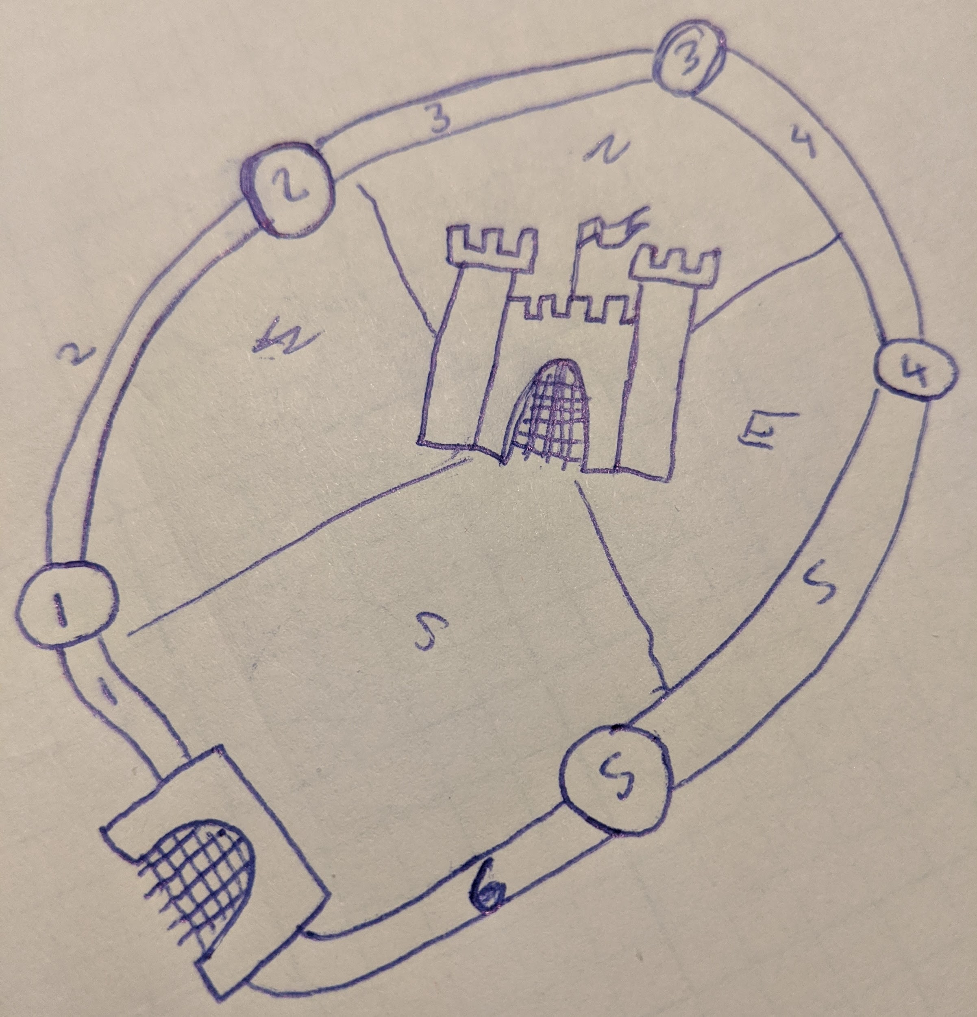

### **Movement**

Characters have a tendency to move around battlefields. Typically characters need to pass DTMS checks to move between zones. Whenever a character is in combat and have a movement action to spend they can move between two logically connected adjacent zones on the battlefield. Atypically characters can move between unconnected zones or zones missing a logical connection by by passing a skill check for a relevant skills. Outside of combat characters can usually move around the battlefield with a large degree of freedom.

## **Damage, wounds, dying, death**

### **Damage**

### **Wounds**

### **Dying**

### **Death**

### **Armor**

### **Weapons**

## **Timing**

This section describes any extended competitive activity within a story where the order of events is relevant. Sword and gun fights certainly fit the mould, sure, but so do a number of other things like horse races, ritual summoning gone wrong, and trying to command a fleet with light-minutes of delay. The order and speed with which characters are allowed to act in this game is based on actions and cooldowns.

### **Tick Length**

In Tabula, timed scenes use ticks, an abstract and arbitrary unit of time to measure how long the scene has lasted and when any individual character can act. The storyteller determines the length of a tick for any given scene. Typically ticks are about a second long but for large scale scenes ticks might be days or even weeks.

### **Action Delay**

Each character has an AD (action delay) stat that governs how quickly they can act in timed scenes. Characters' actions refresh based on their AD. When a number of ticks have passed equal to a character's AD stat that character's [major action](https://github.com/harleydutton/Tabula-Rasa/blob/develop/tabula-rasa.md#major-action), [minor action](https://github.com/harleydutton/Tabula-Rasa/blob/develop/tabula-rasa.md#minor-action), and [reaction](https://github.com/harleydutton/Tabula-Rasa/blob/develop/tabula-rasa.md#reaction) come off of cooldown. The default AD for a setting will be defined on the setting document and represent the typical speed expected for the setting. A higher AD represents a character acting slower than normal and inversely a lower AD represents a character acting faster.

If a character with an AD of 7 acted on 11 that character's actions will refresh on ticks 18, 25, 32, 39, etc. until the scene ends.

### **Global Ticker**

Every timed scene starts with 0 ticks having passed. As a timed scene progresses the storyteller should announce the current tick by counting aloud, one by one. As the global ticker counts up, it is the responsibility of whoever controls a given character to know when that character acts next and call out that it is their turn.

### **Initiative**

To get started with a timed scene each character will need to have a first turn. Each player rolls 1d6 for their character and the storyteller rolls 1d6 for each NPC. This is the turn each character starts on. If a character is joining the scene late, their first turn is 1d6 after the current tick. See the surprise for special cases.

Tim is starting a pie eating contest with two of his friends. When he rolls 3 on 1d6 his first turn is on tick 3. Lets say the tick is 32 and one of the spectators, Joey, has decided he wants to participate. Joey rolls a 5 on 1d6 which means that Joey's first turn will be on tick 37.

### **Surprise**

When one character sneaks up on another using the [hidden information](https://github.com/harleydutton/Tabula-Rasa/blob/develop/tabula-rasa.md#hidden-information) section, and starts something they do not get any benefit. Instead, characters that are surprised are disadvantaged. By default, when a character joins a timed scene they start with all of their actions off cooldown. When a [suspicious](https://github.com/harleydutton/Tabula-Rasa/blob/develop/tabula-rasa.md#suspicious) character joins a timed scene they start with their major action on cooldown. If a character is [oblivious](https://github.com/harleydutton/Tabula-Rasa/blob/develop/tabula-rasa.md#unsuspicious) they start with their major action on cooldown and their cooldowns do not refresh on their first turn.

| **state** | **first turn on tick** | **actions on cooldown** |
| --- | --- | --- |
| default | current tick + 1d6 | none |
| suspicious | current tick + 1d6 | major |
| oblivious | current tick + AD + 1d6 | major |

### **Ties**

When two or more characters would act on the same tick, PCs go before NPCs. If two or more PCs act on the same tick the PC with lower AD acts first. If there is still a tie, break the tie randomly. The storyteller can use this method to break ties for NPCs but doesn't have to.

# **Setting**

A Setting is a template for worldbuilding. It includes a description of the world, the normal speed of characters in the world for combat, the amount of character points new characters in the world start with, a list of Mandatory Skills, and a list of Skills common within the Setting. The description includes the technological level, magic, history, spatial/geographic scope, flora, fauna, biomes, natural resources, items, culture, store, etc. of the World. To be mechanically playable a Setting needs an Action Delay, starting character points, a list of Mandatory Skills, a list of common skills, and a general description. Splitting the description into the cultural and the physical aspects of the world can be helpful. Creating a store is a good idea in most cases (unless you're a communist).

## **Action Delay**

The default Action Delay for the Setting is what all new characters in the Setting will start with. Typically this is 10. This will guarantee that most of the characters in the Setting are at about the same speed in scenes where timing matters like combat and chases. Because it is just a default and can be modified it also allows for some characters to be faster or slower than the average character.

## **Character Points**

Character Points, also known as CP, are a resource used by players throughout the game to take new Skills and Flavor and level up existing skills. The suggested starting character points for a setting is basically a recommendation for starting level. If characters start with 60 CP rather than 50 they will be a little stronger on average. There is usually a positive correlation between the number of mandatory skills in a setting and the starting CP.

## **Skills**

Skills represent things a character can do. Each character within a setting has access to the s same set of skills. Any character can learn these skills with storyteller approval either at character creation or during the story. Players are encouraged to suggest additions to the list of skills on the setting. A few examples of skills are sword-fighting, necromancy, seduction, and piloting. Skills can be purchased with CP at character creation and during the story by any character. Characters do not need to have every skill.

Available skills can be purchased with CP at character creation and during the story by any character. Characters do not need to have every available skill.

## **Technology and Magic Descriptions**

A couple of initial questions players usually have when they are making characters in a new setting are "Is there magic?" and "What is the technological level?" and for this reason the answers to these questions should be on the setting. They are commonly asked, important, and usually easy to answer. If there is any fictitious magic in the setting it should be described here.

## **Store**

First off *the* store doesn't really exist after character creation. Characters will have to go to stores in the story to purchase things listed on *the* store. Going to *a* store within the story rather than *the* store will drastically affect what is available for sale and maybe even what it is legal to trade. This is all subject to DTMS checks and storyteller approval after character creation. Anyway, *the* store is set up as a series of priced columns. The flavor section describes the purchasing power of various pieces of flavor-money, also known as purchases. The columns should be "Trivial", "Minor", "Major", and "impossible". Trivial purchases are effectively free, minor purchases are worth one CP, major purchases need to be roleplayed for or a deal needs to be struck, and impossible purchases are typically too expensive to ever purchase. Impossible purchases may become available through roleplaying. The columns of the store should all have things characters can purchase in/under them as reference points.

Trivial purchases are things like food, beer, candy, ammo, clothes, or entertainment. A minor purchase would be something that costs more a gun, car, specialized tool, computer, or medicine. Major purchases would be things like houses, companies, famous art, fancy cars, or a college education. Some impossible purchases would be space shuttles, whole countries, or world-famous art.

## **Tone**

It is typically a good idea to set expectations for the tone of the story such that people have the same expectations for the game and those expectations are met. It can ruin a horror campaign to have a bunch of goofy shit happening all the time. It can ruin a serious campaign to have a character named reginald fuck-hammer. Similarly it can ruin a goofy space-romp to have a character with a depressing or sinister history.

## **Social Description**

The social description for the setting should describe what the people of the setting are like and what they have done. This will be things like important places, institutions, cultural events, and historic events. This will also include the races/peoples/cultures within the setting and the countries and governments they have formed.

## **Physical Description**

The physical description for the setting should describe what the land itself is like (assuming there is land). This would be things like geography, weather, plants, and animals. This should also include scope; how large an area does this description cover? A city? A country? A continent? A planet? A map will supplement this description nicely. The spatial scope can be the entire known universe or just the part the characters are in right now. A rough idea of how big it is will always help players wrap their heads around it though.

## **Theme**

Each setting has a theme. It might be the wild west with cowpokes getting into brawls and lobbing dynamite off of trains. It might be an epic swords and sorceries adventure. It might be a modern day espionage story with lots of gunfights and back alley deals. It might be the far flung future with spaceships battling around every asteroid. The point is that players should try to match their characters to the theme of the setting as well as they can. Usually the storyteller doesn't enjoy telling you you cannot play a wizard in the story about space pirates.

# **Character**

This chapter is for you, the Player. Characters are representations of the fictional people within the Setting. To be mechanically playable, your character needs an action delay, a motivation, skills, flavor and a number of other shit.

## **Identification Information**

This info is of little relevance to a character and of great relevance to the actual human people playing them. This stuff is useful to put on your sheet to keep things from getting lost or disorganized but you are welcome to skip it.

* Name: The character's name
* Concept: a short stereotypical description of your character
* Player: The player's name
* Setting: The name of the character's setting
* Story: The name of the story the character was in**.**

## **Action Delay**

This is how fast a character is. Making it lower makes the character faster. See [combat](https://github.com/harleydutton/Tabula-Rasa/blob/develop/tabula-rasa.md#combat) for an explanation of how action delay works.

## **Character Points**

Character points are used to make a character stronger. They can be used to get new skills and flavor, level up skills, decrease action delay, and acquire minor purchases.

## **Motivations**

Characters must have at least one motivation. Motivations can be Ideals, Values, Causes, or anything else that gets the character out of bed in the morning.

Alice is motivated by escaping wonderland and finding her way home. Harry is motivated to defeat the dark lord to protect his friends.

## **Skills**

Each character has a list of skills representing the actions they can take in the story. Skills do have to be things that a character can *do* which also means they have to be able to fail as well. Skills can be either mandatory or available. All characters must have at least one level in all mandatory skills. Otherwise characters may take levels in available skills unless it doesn't make sense.

## **Attributes**

Attributes are very similar to skills with a few exceptions. Like skills, attributes can be used to roll checks but unlike skills attributes are as broad in scope as they can be. Like skills, attributes can be leveled up using CP but they are far more expensive. Unlike skills, attributes act as a character's physical, mental, spiritual, and social health. Furthermore, attributes are often used defensively when no other skill would apply. Lastly, attributes can and often are used for perception checks.

## **Skills**

Each character has a list of skills representing the actions they can take in the story. Skills do have to be things that a character can *do* which also means they have to be able to fail as well. Characters may take levels in any skills listed on the setting document unless it wouldn't make sense for them to do so. Skills can be rare or common like surgery and driving are in modern times or more outlandish like necromancy.

## **Flavor**

Flavor is a mechanic in Tabula used to describe the interesting parts of a character. Almost anything unique that a character *is* or *has* is likely to be flavor. Flavor is used primarily for DTMS (does this make sense) checks and modifying the difficulty on checks. Flavor cannot refer to any part of the system, including AD, skills, or attributes. A few examples of flavor might be armor, horse, landed noble, flaming sword, elf, big and tall, etc. for an elvish knight of the summer court. Each piece of flavor should be a short, evocative description.

### **Bad Flavor**

Negative Flavor is usually acquired in two ways. The first way is usually through deals. Rather than asking for a piece of flavor that does something good and something bad a player might ask for a piece of flavor that is mostly bad and ask that it not cost them CP. If the storyteller agrees that this is bad flavor then you can take it for free. The second way characters usually get negative flavor is from combat. When one character lops off another character's hand with a sword that new -1 hand will need to be remembered unless that character ceases to matter. Flavor can handle arbitrary negative effects like wounds perfectly.

### **Deals**

At character creation you may have noticed that there is no way to modify action delay. There is also no way to get any special racial abilities. There is also no way to become rich and famous. Etc. The point is you have to talk to the storyteller when you are creating your character, ask for the things you want, and represent them as flavor. Sometimes the things you want are OP as shit and the DM will want to keep your character in line by raising the cost above the normal for what you are asking for. Want to be super fast? Have -2 action delay by being a vampire (instead death by sunlight). Want to be big enough you can throw cars? Become an Ent for +3 action delay and a vulnerability to fire. Perhaps you can be a world famous boxer if you also have some gambling debts. The point is, talk to your DM and work it out. Sometimes it is appropriate to add a deal to the setting such that it is available to all players and NPCs.

### **Items**

Unlike most other roleplaying games which have extensive tables for equipment, in Tabula I have opted to represent equipment as flavor. This means that armor, weapons, tools, vehicles, and treasure should be represented as flavor. Typically equipment will modify the difficulty of checks with relevant skills sometimes reducing the difficulty from impossible and effectively granting a character new abilities.

### **Money**

Money is represented as flavor in Tabula. Character points can be converted into minor purchases. Money-flavor represents a character's liquid assets or the stuff they have for trade. Money-flavor can be aliased to whatever the currency for you game is: gold coins, spacebucks, dollars, bullets, litres (of water), etc. If you want to know more go visit the [Money](https://github.com/harleydutton/Tabula-Rasa/blob/develop/tabula-rasa.md#money-1) section. Typically money can be spent on things on the settings store as long as you find a store selling that thing in-game.

### **Social Flavor**

The in-game doors that position and status unlock are also represented by flavor. Typically this might look like respected businessman, landed noble, kings advisor, or internet personality. The effect of this stuff is purely RP and it will be up to the player to use it to its fullest. A character's job is always worth having as flavor because this has social implications in most societies. A character may or may not have a reputation but if they do it is worth putting down what it is and what group of people will know about it.

### **Supernatural Flavor**

Supernatural flavor is how one might represent being a priest to a specific god. Seriously just put down priest of Khorn to be that. Similarly if a character is haunted, blessed, or in a demonic pact just put those things down. That covers the social aspect of supernatural flavor. On the other hand a character could be magically adept, unnaturally sweaty, or the chosen one.

### **Relationships**

If you have another character as a companion you should list them as flavor or make a character sheet for them. Any animal companions, demonic familiars, slaves, shipboard AI, or loyal friends should be either listed as flavor or have their own character sheet made or both. Whatever is most apt. Consult the deals section and the storyteller.

### **Knowledge**

Knowledge should be represented as flavor unless that knowledge would be better represented as a skill. You cannot have a flavor and skill that are functionally identical such that the flavor just lowers the difficulty on all of that skills checks. Languages, secrets, history, specific domains of skilled labor, culture, religious rites, etc. are all examples of in character knowledge that should be represented as flavor.

### **Vehicles and Properties**

Horses, boats, spaceships, cars, planes, tanks, etc. Houses, castles, countries, skyscrapers, private islands, secret bases, etc.

### **Physical**

Physicality is also represented as flavor. This includes but is not limited to body type, species, race, deformities, aesthetic, and disabilities. An example of each, in order, would be fat, human, white, missing an ear, well dressed, and peg-leg.

# **Glossary of Terms**

* Storyteller: The storyteller is the guy telling the story. In other games you might have heard this person referred to as the DM (Dungeon Master) or GM (Game Master).
* Players: Players are the humans playing a roleplaying game who aren't the storyteller.
* Characters: Characters are the (usually) imaginary people within the world of the roleplaying game and story.
* Player Characters: Player Characters, also known as PCs, are the characters the players control.
* Non-Player Characters: Non-Player Characters, also known as NPCs, are those characters not controlled by players.
* Worldbuilding: Worldbuilding is where a real human person takes some time and thinks up an imaginary world.
* Roleplaying: Roleplaying, also known as RPing, is where a human person dons the personality of a character and begins using method (voice) acting to indicate that characters actions to the other players and storyteller.
* Setting: A setting is the result of worldbuilding applied to the setting template present in Tabula
* Battlegrid: A battlegrid is a checkerboard or hex-tiled board game board, usually accompanied by figurines, that visually represents locations for combat in a roleplaying game.
* RPG: Roleplaying Game. Also sometimes known as Table-top, or Table-top RPG.